

**République Algérienne Démocratique et Populaire**

**Ministère de l’éducation nationale**

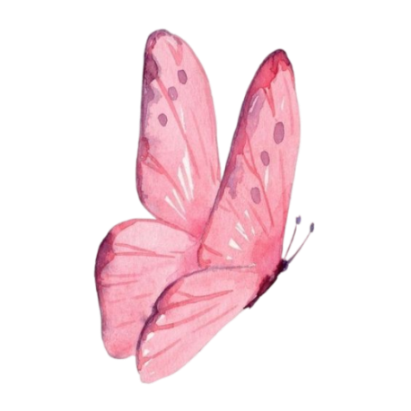**Direction de l’éducation de la wilaya de …………….…**

****Enseignante: ………………………

**Année scolaire :**.

**2025 -2026**





|  |
| --- |
| **4AP** |

|  |
| --- |
| **3AP** |

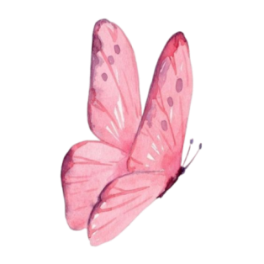



|  |
| --- |
| **5AP** |

|  |
| --- |
| **L’évaluation des acquis** |

|  |  |  |  |  |  |  |  |
| --- | --- | --- | --- | --- | --- | --- | --- |
| **Grille d’évaluation continue** | | | | | | | |
| **Moyenne** | **Examen** | **Total** | **Production écrite** | **Lecture + comptine** | **Oral** | **NOM ET PRENOM** | **N** |
|  |  |  |  |  |  |  | **01** |
|  |  |  |  |  |  |  | **02** |
|  |  |  |  |  |  |  | **03** |
|  |  |  |  |  |  |  | **04** |
|  |  |  |  |  |  |  | **05** |
|  |  |  |  |  |  |  | **06** |
|  |  |  |  |  |  |  | **07** |
|  |  |  |  |  |  |  | **08** |
|  |  |  |  |  |  |  | **09** |
|  |  |  |  |  |  |  | **10** |
|  |  |  |  |  |  |  | **11** |
|  |  |  |  |  |  |  | **12** |
|  |  |  |  |  |  |  | **13** |
|  |  |  |  |  |  |  | **14** |
|  |  |  |  |  |  |  | **15** |
|  |  |  |  |  |  |  | **16** |
|  |  |  |  |  |  |  | **17** |
|  |  |  |  |  |  |  | **18** |
|  |  |  |  |  |  |  | **19** |
|  |  |  |  |  |  |  | **20** |
|  |  |  |  |  |  |  | **21** |
|  |  |  |  |  |  |  | **22** |
|  |  |  |  |  |  |  | **23** |
|  |  |  |  |  |  |  | **24** |
|  |  |  |  |  |  |  | **25** |
|  |  |  |  |  |  |  | **26** |
|  |  |  |  |  |  |  | **27** |
|  |  |  |  |  |  |  | **28** |
|  |  |  |  |  |  |  | **29** |
|  |  |  |  |  |  |  | **30** |
|  |  |  |  |  |  |  | **31** |
|  |  |  |  |  |  |  | **32** |
|  |  |  |  |  |  |  | **33** |
|  |  |  |  |  |  |  | **34** |
|  |  |  |  |  |  |  | **35** |
|  |  |  |  |  |  |  | **36** |
|  |  |  |  |  |  |  | **37** |
|  |  |  |  |  |  |  | **38** |
|  |  |  |  |  |  |  | **39** |
|  |  |  |  |  |  |  | **40** |

Enseignante : Directeur(trice) : Inspecteur(trice) :

**Direction de l’éducation de la wilaya de …………….… Année scolaire :**. **2025 -2026**

**Etablissement scolaire :……….** Enseignant(e) :

|  |  |  |  |  |  |  |  |  |  |  |  |  |  |  |
| --- | --- | --- | --- | --- | --- | --- | --- | --- | --- | --- | --- | --- | --- | --- |
| **Grille d’évaluation des acquis**  **Compréhension et communication orales** | | | | | | | | | | | | | | |
| **S’exprimer en fonction de la situation de communication** | | | | **Identifier les unités de sens** | | | | **Identifier le thème de la situation de communication** | | | | | **Critères**  Niveaux de maitrise | |
| **D** | **C** | **B** | **A** | **D** | **C** | **B** | **A** | **D** | **C** | **B** | **A** | **NOM ET PRENOM** | | **N** |
|  |  |  |  |  |  |  |  |  |  |  |  |  | | **01** |
|  |  |  |  |  |  |  |  |  |  |  |  |  | | **02** |
|  |  |  |  |  |  |  |  |  |  |  |  |  | | **03** |
|  |  |  |  |  |  |  |  |  |  |  |  |  | | **04** |
|  |  |  |  |  |  |  |  |  |  |  |  |  | | **05** |
|  |  |  |  |  |  |  |  |  |  |  |  |  | | **06** |
|  |  |  |  |  |  |  |  |  |  |  |  |  | | **07** |
|  |  |  |  |  |  |  |  |  |  |  |  |  | | **08** |
|  |  |  |  |  |  |  |  |  |  |  |  |  | | **09** |
|  |  |  |  |  |  |  |  |  |  |  |  |  | | **10** |
|  |  |  |  |  |  |  |  |  |  |  |  |  | | **11** |
|  |  |  |  |  |  |  |  |  |  |  |  |  | | **12** |
|  |  |  |  |  |  |  |  |  |  |  |  |  | | **13** |
|  |  |  |  |  |  |  |  |  |  |  |  |  | | **14** |
|  |  |  |  |  |  |  |  |  |  |  |  |  | | **15** |
|  |  |  |  |  |  |  |  |  |  |  |  |  | | **16** |
|  |  |  |  |  |  |  |  |  |  |  |  |  | | **17** |
|  |  |  |  |  |  |  |  |  |  |  |  |  | | **18** |
|  |  |  |  |  |  |  |  |  |  |  |  |  | | **19** |
|  |  |  |  |  |  |  |  |  |  |  |  |  | | **20** |
|  |  |  |  |  |  |  |  |  |  |  |  |  | | **21** |
|  |  |  |  |  |  |  |  |  |  |  |  |  | | **22** |
|  |  |  |  |  |  |  |  |  |  |  |  |  | | **23** |
|  |  |  |  |  |  |  |  |  |  |  |  |  | | **24** |
|  |  |  |  |  |  |  |  |  |  |  |  |  | | **25** |
|  |  |  |  |  |  |  |  |  |  |  |  |  | | **26** |
|  |  |  |  |  |  |  |  |  |  |  |  |  | | **27** |
|  |  |  |  |  |  |  |  |  |  |  |  |  | | **28** |
|  |  |  |  |  |  |  |  |  |  |  |  |  | | **29** |
|  |  |  |  |  |  |  |  |  |  |  |  |  | | **30** |
|  |  |  |  |  |  |  |  |  |  |  |  |  | | **31** |
|  |  |  |  |  |  |  |  |  |  |  |  |  | | **32** |
|  |  |  |  |  |  |  |  |  |  |  |  |  | | **33** |
|  |  |  |  |  |  |  |  |  |  |  |  |  | | **34** |
|  |  |  |  |  |  |  |  |  |  |  |  |  | | **35** |
|  |  |  |  |  |  |  |  |  |  |  |  |  | | **36** |
|  |  |  |  |  |  |  |  |  |  |  |  |  | | **37** |
|  |  |  |  |  |  |  |  |  |  |  |  |  | | **38** |
|  |  |  |  |  |  |  |  |  |  |  |  |  | | **39** |
|  |  |  |  |  |  |  |  |  |  |  |  |  | | **40** |

Enseignante : Directeur(trice) : Inspecteur(trice) :

